**Avery (Aves) Wilde** 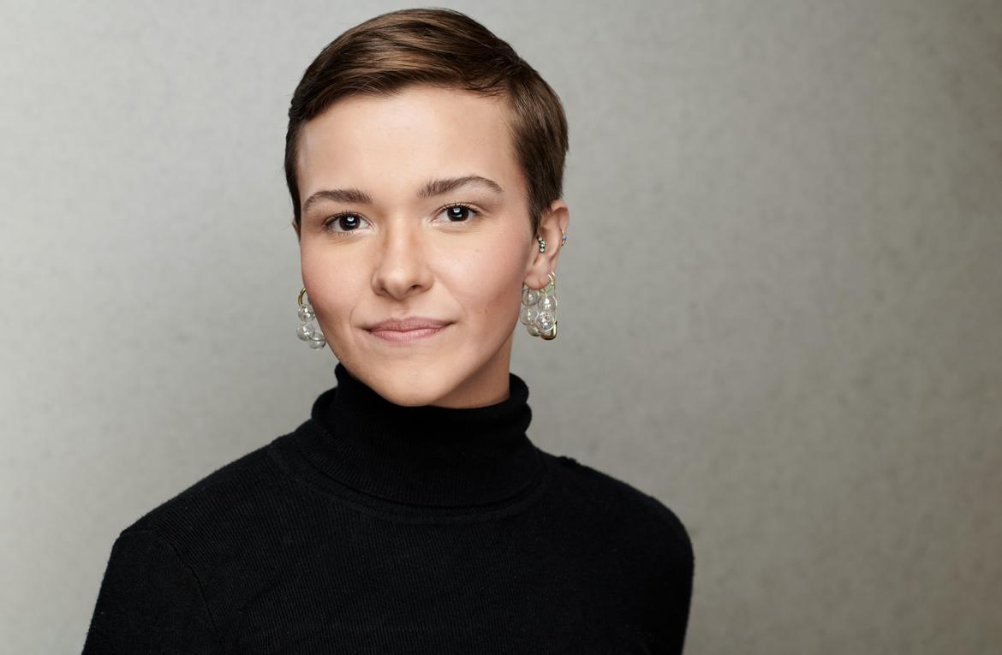

**they/them**

Height: 5’ 3”

(419) 606-3556

averydancer19@gmail.com

**Performance**

*Love Big Enough* Trio, Soloist, Ensemble Erin Murphy, Nina-Rose

Wardanian, Paula Sousa

*Wonder*  Dancer Tyler Thompson, Pauline Mosley

*Without Regret* / Noumenon Dance Ensemble Trio, Soloist, Ensemble Erin Murphy, Nina-Rose

Wardanian, Paula Sousa

*INFJ* / Modern Marvels Dance Company Soloist, Ensemble Kate O’Hanlon Bruns

*Under my Skin /* Noumenon Dance Ensemble Trio, Soloist, Ensemble Erin Murphy, Nina-Rose

Wardanian, Paula Grahmann

*Ellas y Yo Mexicanas/* Sildance/Acrodanza Dancer Silvita Diaz Brown

*Following Shadows* / Noumenon Dance Ensemble Dancer Erin Murphy, Nina-Rose

Wardanian, Paula Grahmann

*Hat Fantasia (Does Anyone?)* / Point Park University Dancer Jesse Factor

*(in effect) /* Point Park University Dancer Pearlann Porter

*Here isn’t Forever /* Point Park UniversityDancer Pearlann Porter

*La Bayadère /* Point Park University Corps Susan Stowe (staged by)

**Company Experience**

Noumenon Dance Ensemble : ‘23-’24 Season & ‘24-’25 Season

Modern Marvels Dance Company : ‘23-’24 Season & ‘24-’25 Season

773 Dance Project : ‘24-’25 Season

Echo Modern Dance Collective : ‘23-’24 Season

Shana Simmons Dance : ‘20-’21 Season & ‘21-’22 Season

**Education**

Point Park University ‘23 Bachelors of Fine Arts in Dance, Concentration in Modern,

Nonprofit Business Management minor

**Related Experience**

Boston Dance Theater Winter Immersion Project ‘23

*Sense and Sensibility* / Pittsburgh Playhouse Choreographer

**Additional Information:**

* Pointe
* Tap
* Covid-19 Vaccinated
* U.S. Passport